Exercise 1: Control Structures
Scenario 1
SET SERVEROUTPUT ON;
CREATE TABLE Customers (
CustomerID NUMBER PRIMARY KEY,
Name VARCHAR2(100),
DOB DATE,
Balance NUMBER,
LastModified DATE
);
CREATE TABLE Accounts (
AccountID NUMBER PRIMARY KEY,
CustomerID NUMBER,
AccountType VARCHAR2(20),
Balance NUMBER,
LastModified DATE,
FOREIGN KEY (CustomerID) REFERENCES Customers(CustomerID)
);
CREATE TABLE Loans (
LoanID NUMBER PRIMARY KEY,
CustomerID NUMBER,
LoanAmount NUMBER,
InterestRate NUMBER,
StartDate DATE,
EndDate DATE,
FOREIGN KEY (CustomerID) REFERENCES Customers(CustomerID)
);
CREATE TABLE Transactions (
TransactionID NUMBER PRIMARY KEY,
AccountID NUMBER,
TransactionDate DATE,
Amount NUMBER,
TransactionType VARCHAR2(10),
FOREIGN KEY (AccountID) REFERENCES Accounts(AccountID)
);
CREATE TABLE Employees (
EmployeeID NUMBER PRIMARY KEY,
Name VARCHAR2(100),
Position VARCHAR2(50),
Salary NUMBER,
Department VARCHAR2(50),
HireDate DATE
);
INSERT INTO Customers (CustomerID, Name, DOB, Balance,
LastModified) VALUES (1, 'John Doe',
TO_DATE('1985-05-15', 'YYYY-MM-DD'), 1000, SYSDATE);

INSERT INTO Customers (CustomerID, Name, DOB,
Balance, LastModified) VALUES (2, 'Jane Smith',
TO_DATE('1990-07-20', 'YYYY-MM-DD'), 1500, SYSDATE);

INSERT INTO Accounts (AccountID, CustomerID, AccountType,
Balance, LastModified) VALUES (1, 1, 'Savings', 1000,
SYSDATE);

INSERT INTO Accounts (AccountID, CustomerID, AccountType,
Balance, LastModified) VALUES (2, 2, 'Checking', 1500,
SYSDATE);

INSERT INTO Transactions (TransactionID, AccountID,
TransactionDate, Amount, TransactionType) VALUES
(1, 1, SYSDATE, 200, 'Deposit');

INSERT INTO Transactions (TransactionID, AccountID,
TransactionDate, Amount, TransactionType) VALUES
(2, 2, SYSDATE, 300, 'Withdrawal');

INSERT INTO Loans (LoanID, CustomerID, LoanAmount,
InterestRate, StartDate, EndDate) VALUES (1, 1, 5000,
5, SYSDATE, ADD_MONTHS(SYSDATE, 60));

INSERT INTO Employees (EmployeeID, Name, Position,
Salary, Department, HireDate) VALUES (1, 'Alice Johnson',
'Manager', 70000, 'HR', TO_DATE('2015-06-15',
'YYYY-MM-DD'));

INSERT INTO Employees (EmployeeID, Name, Position,
Salary, Department, HireDate) VALUES (2, 'Bob Brown',
'Developer', 60000, 'IT', TO_DATE('2017-03-20',
'YYYY-MM-DD'));

DECLARE
v_age NUMBER;
BEGIN
FOR c IN (SELECT CustomerID, DOB FROM Customers) LOOP

v_age := FLOOR(MONTHS_BETWEEN(SYSDATE, c.DOB)/12);

IF v_age > 60 THEN
UPDATE Loans
SET InterestRate = InterestRate - 1
WHERE CustomerID = c.CustomerID;
END IF;

END LOOP;

COMMIT;
END;
/
SELECT * FROM Loans;

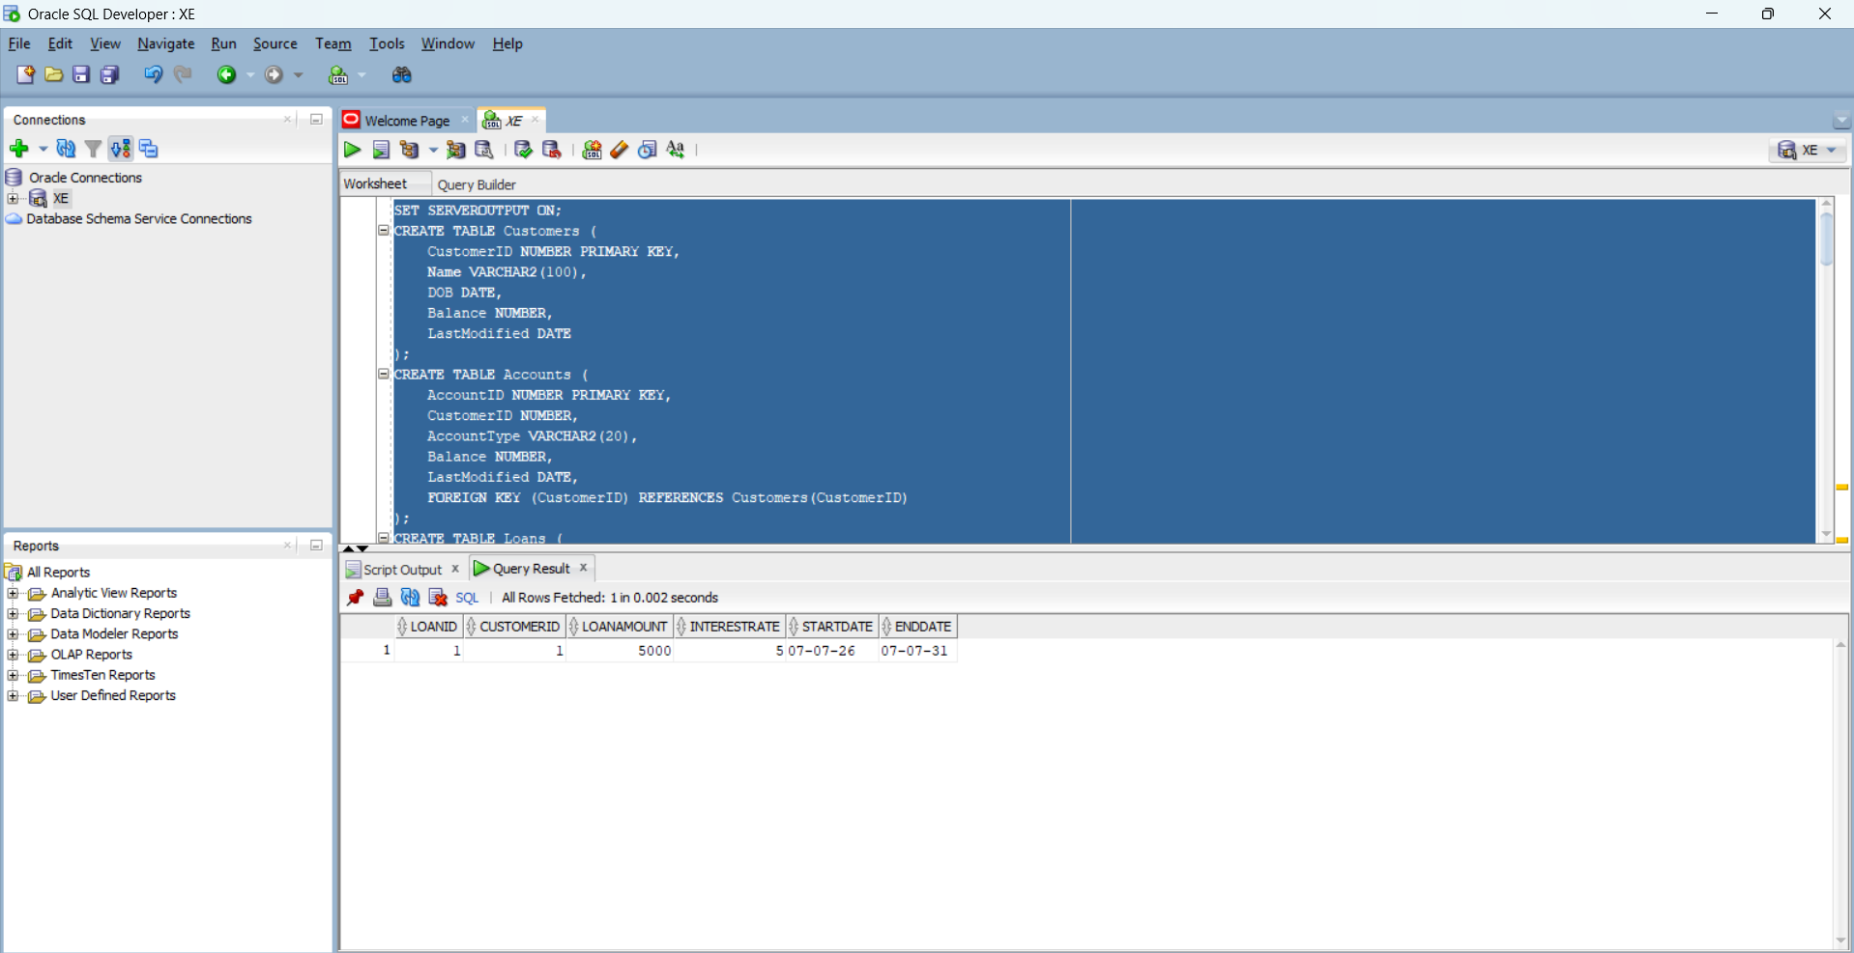

Scenario 2
SET SERVEROUTPUT ON;
SELECT LoanID, CustomerID, EndDate FROM Loans;
UPDATE Loans
SET EndDate = SYSDATE - 5;
COMMIT;
DECLARE
BEGIN
FOR l IN (SELECT LoanID, CustomerID, EndDate FROM Loans) LOOP
IF l.EndDate < SYSDATE THEN
DBMS_OUTPUT.PUT_LINE(
'Loan overdue for CustomerID: ' || l.CustomerID
);
END IF;
END LOOP;
END;/

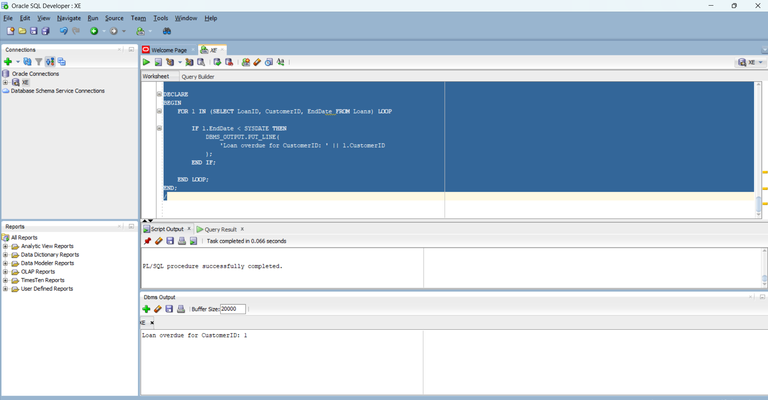

Scenario 3

SELECT LoanID,
CustomerID,
TO_CHAR(EndDate,'DD-MON-YYYY') AS END_DATE
FROM Loans;
UPDATE Loans
SET EndDate = SYSDATE + 20
WHERE LoanID = 1;
COMMIT;
SELECT LoanID,
CustomerID,
TO_CHAR(EndDate,'DD-MON-YYYY') AS END_DATE
FROM Loans;
BEGIN
FOR l IN
(
SELECT c.Name,
l.LoanID,
l.EndDate
FROM Customers c
JOIN Loans l
ON c.CustomerID = l.CustomerID
WHERE l.EndDate BETWEEN SYSDATE AND SYSDATE + 30
)
LOOP
DBMS_OUTPUT.PUT_LINE(
'Reminder: Dear ' || l.Name ||
', your Loan ID ' || l.LoanID ||
' is due on ' || TO_CHAR(l.EndDate,'DD-MON-YYYY')
);
END LOOP;
END;
/
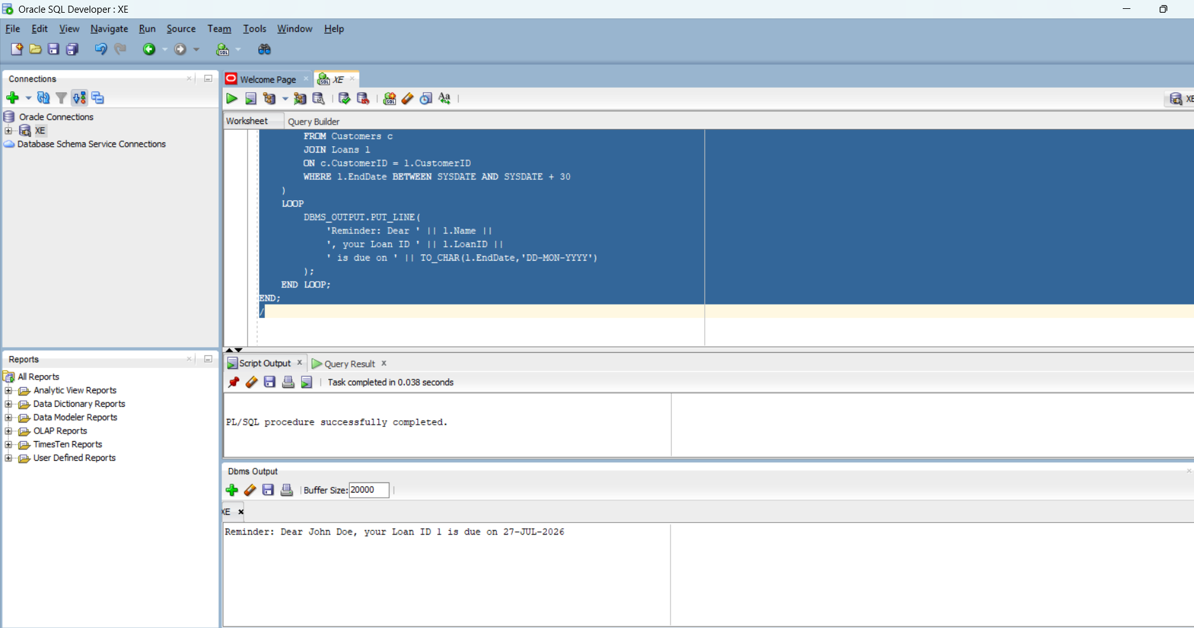

Exercise 3: Stored Procedures
Scenario 1
CREATE OR REPLACE PROCEDURE ProcessMonthlyInterest
IS
BEGIN
UPDATE Accounts
SET Balance = Balance + (Balance * 0.01)
WHERE AccountType = 'Savings';
COMMIT;
DBMS_OUTPUT.PUT_LINE('Monthly interest applied successfully.');
END;
/
EXEC ProcessMonthlyInterest;
SELECT AccountID,
AccountType,
Balance
FROM Accounts;
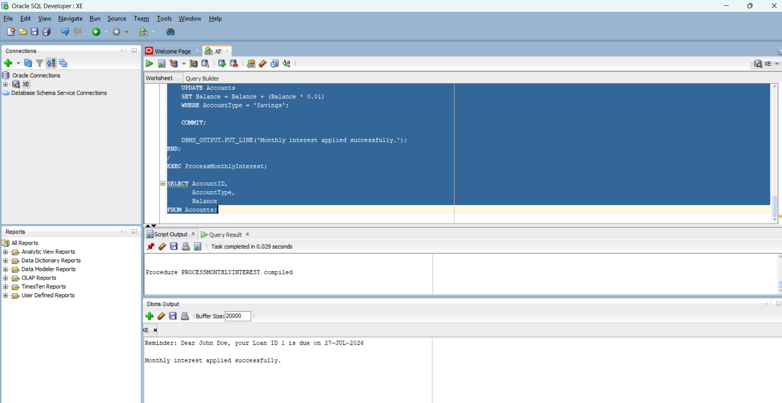

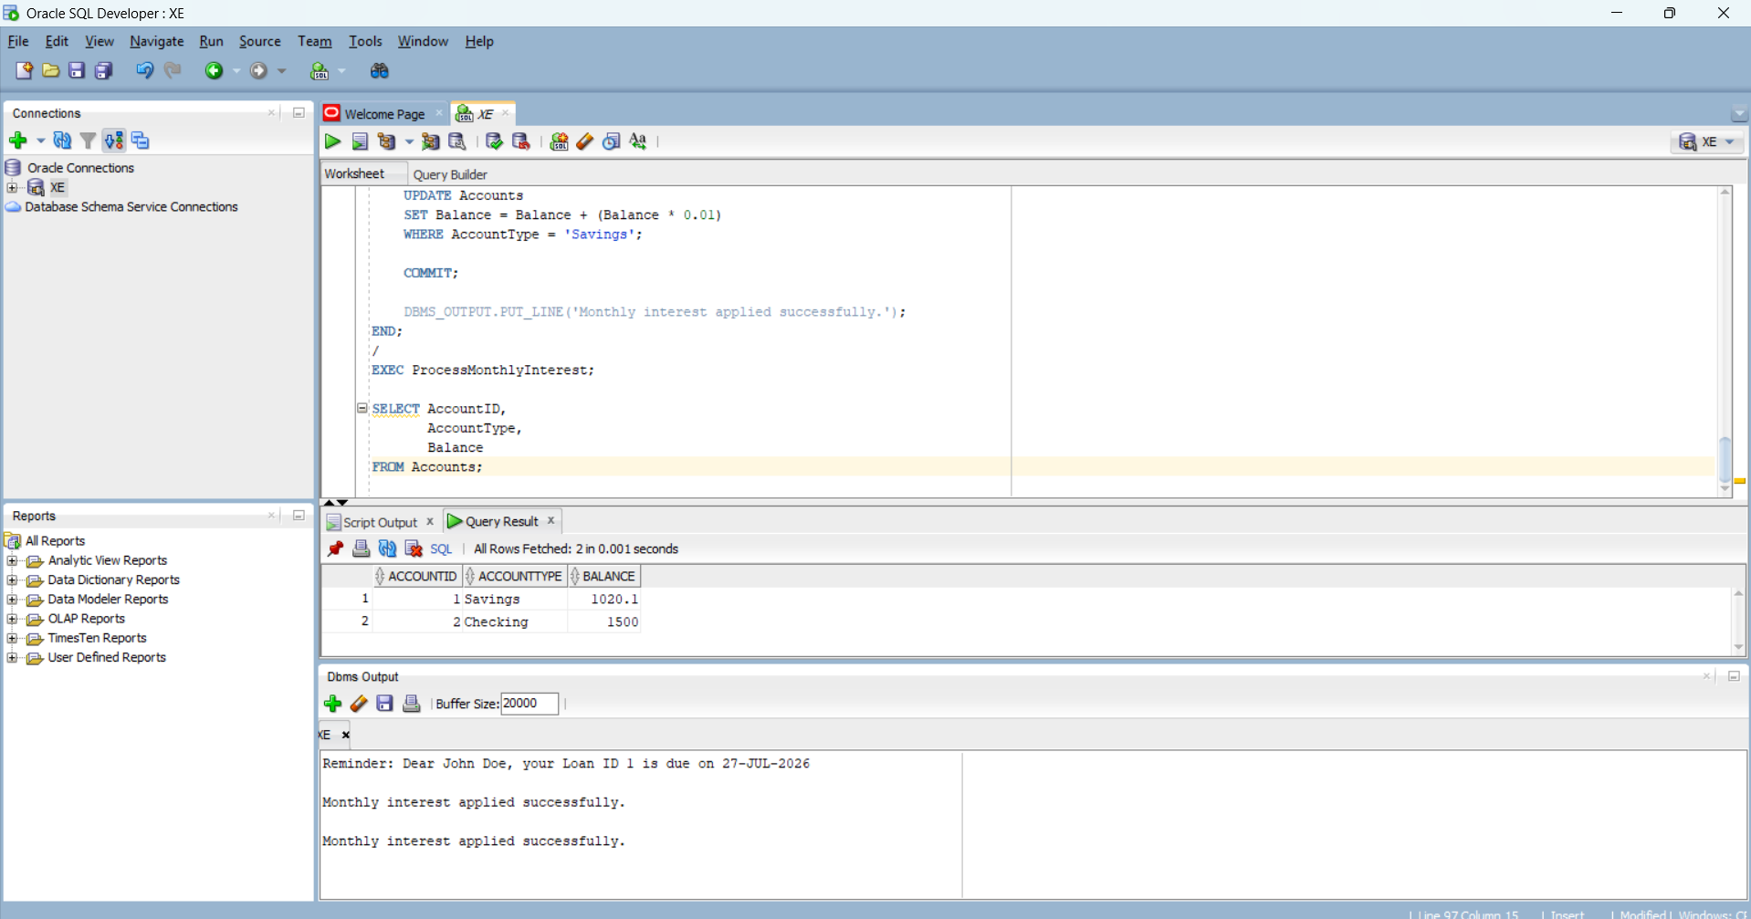

Scenario 2
CREATE OR REPLACE PROCEDURE UpdateEmployeeBonus(
p_department IN VARCHAR2,
p_bonus_percent IN NUMBER
)
IS
BEGIN
UPDATE Employees
SET Salary = Salary + (Salary * p_bonus_percent / 100)
WHERE Department = p_department;

COMMIT;

DBMS_OUTPUT.PUT_LINE('Bonus updated successfully for ' || p_department || ' department.');
END;
/

EXEC UpdateEmployeeBonus('IT',10);
SELECT EmployeeID,
Name,
Department,
Salary
FROM Employees;
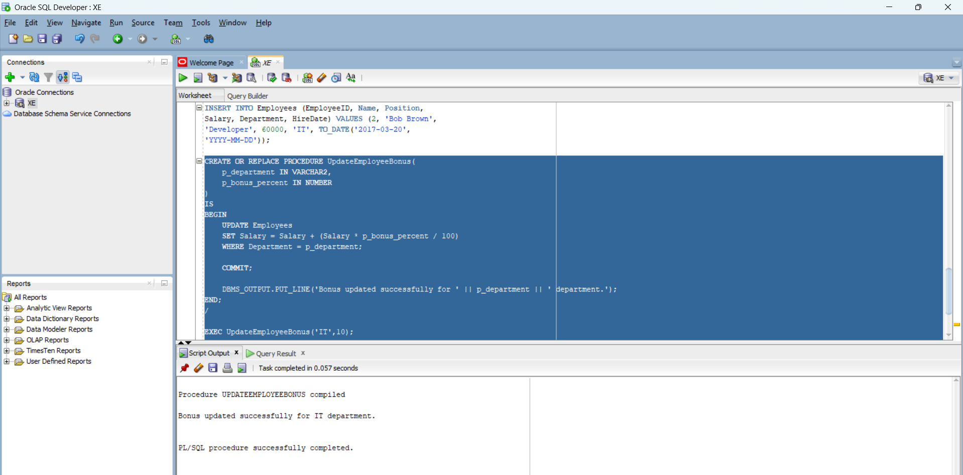

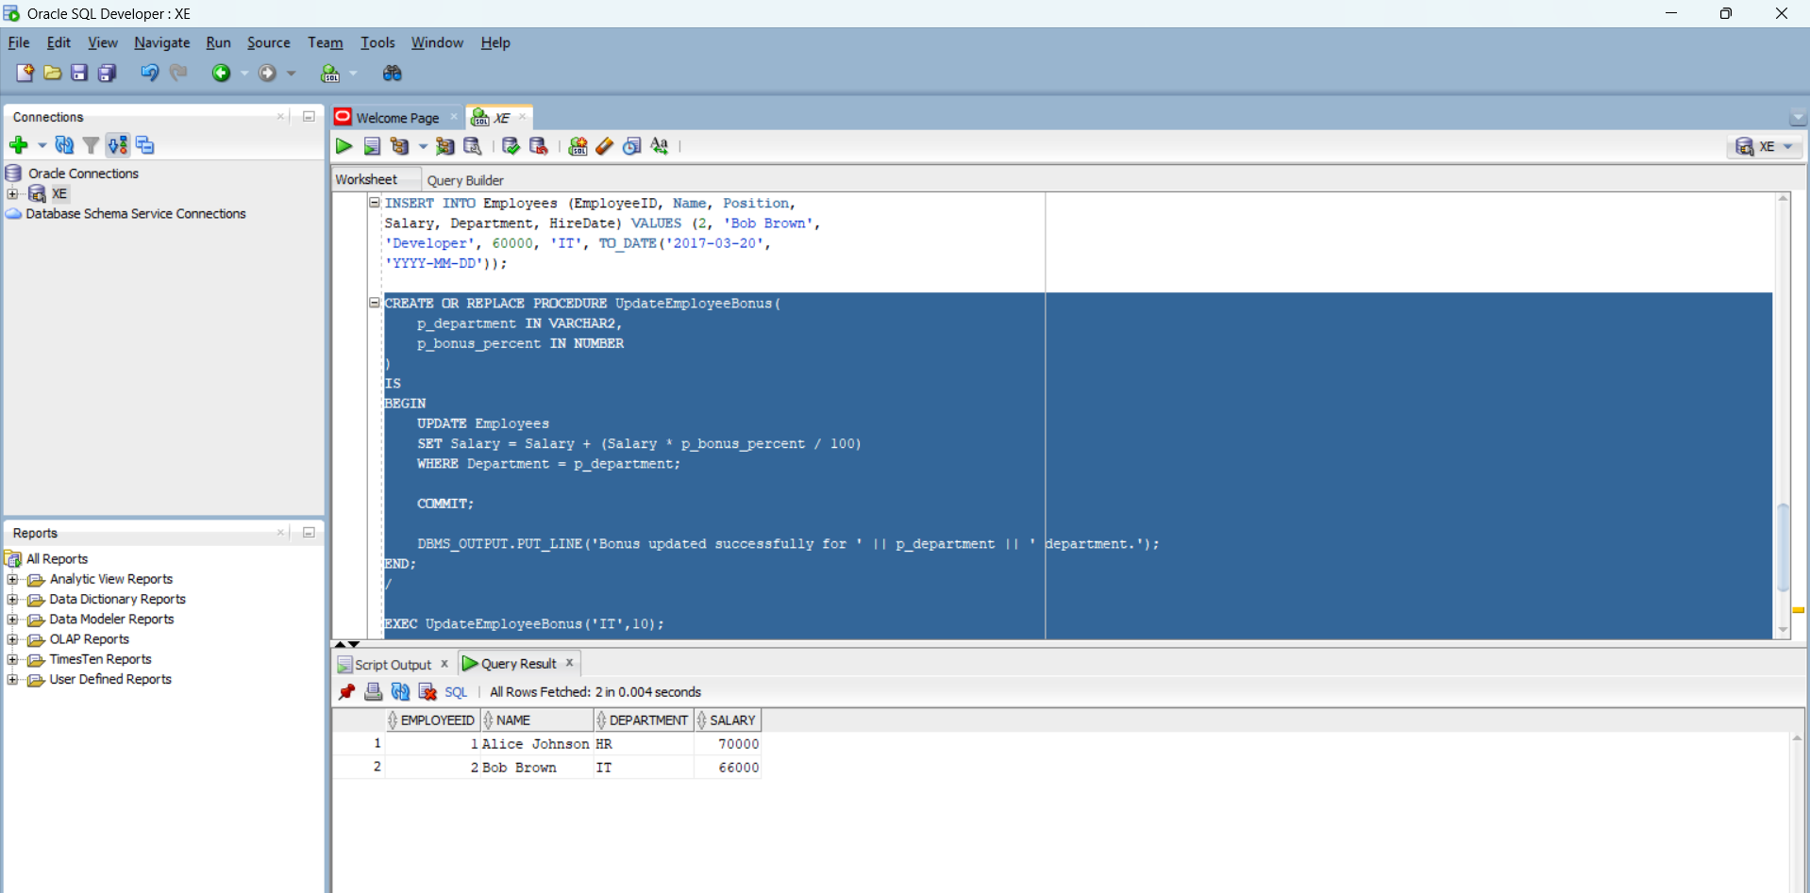

Scenario 3
CREATE OR REPLACE PROCEDURE TransferFunds(
p_FromAccount IN NUMBER,
p_ToAccount IN NUMBER,
p_Amount IN NUMBER
)
IS
v_Balance NUMBER;
BEGIN
-- Get balance of source account
SELECT Balance
INTO v_Balance
FROM Accounts
WHERE AccountID = p_FromAccount;

-- Check sufficient balance
IF v_Balance >= p_Amount THEN

-- Deduct from source account
UPDATE Accounts
SET Balance = Balance - p_Amount
WHERE AccountID = p_FromAccount;

-- Add to destination account
UPDATE Accounts
SET Balance = Balance + p_Amount
WHERE AccountID = p_ToAccount;

COMMIT;

DBMS_OUTPUT.PUT_LINE('Funds transferred successfully.');

ELSE
DBMS_OUTPUT.PUT_LINE('Insufficient Balance.');
END IF;

EXCEPTION
WHEN NO_DATA_FOUND THEN
DBMS_OUTPUT.PUT_LINE('Invalid Account Number.');
END;
/

EXEC TransferFunds(1,2,500);

SELECT AccountID,
AccountType,
Balance
FROM Accounts;
